Technical University of Cluj-Napoca
Automation and Computer Science Faculty
Automation and Applied Informatics

Student : | Coordinator:
Group: | Assist. Eng. Dan Gota
2016-2017

Summary

Contents
Drafting 1 2
Drafting 2 2
OpenGL 2
LISP 2
Explanatory Note 2

Use the current template to finalize the documentation.
Bring a hardcopy of this file and the printed drawing files. For the hardcopy, use the following type of file folder:
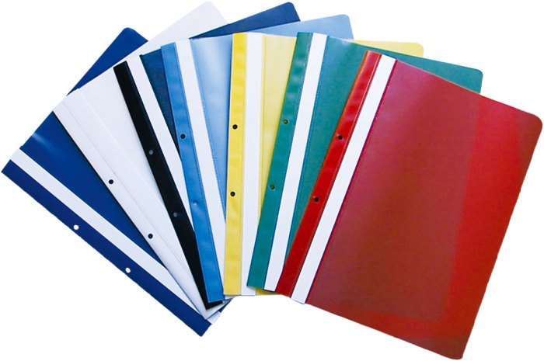
Bring the zip file with all the resources as presented by the zip template.
Deadline: the lab exam.

Drafting 1
- Add description of the object and the commands used to finalize the part 1(1/2 pag)
- Add pictures of the object.
- Add the hyperlink resource into the CAD1 folder.
- Print the drawing for the printed version of this document.

Drafting 2
- Add the description of the process and the commands used to finalize the part 2(1 pag)
- Add the hyperlink resource into the CAD2 folder.
- Add the Bibliography used (hyperlinks or other).
- Print the drawing for the printed version of this document.

OpenGL
- Add the objective and a short description of the program.
- Add the source code with comments.
- Add print screens of the output window.
- Add the hyperlink resource (the entire project) into the OpenGL folder.
- Add the Bibliography used (hyperlinks or other).

LISP
- Add description of the program.
- Add the source code with comments.
- Add the hyperlink resource, into the LISP folder.
- Add print screens with before and after nthe command created.
- Add the Bibliography used (hyperlinks or other).

Explanatory Note

Regarding the Bibliography template, see next:
https://www.ieee.org/documents/ieeecitationref.pdf

